Hands-on Lab: Get to know Watson Discovery

**Estimated time needed:** 30 minutes

Lab Overview

In this hands-on lab, you will get to know the Watson Discovery service. We'll start by creating an instance of the service, launching the Watson Discovery console, and then running queries with the Watson Discovery News data set.

Objectives

After completing this lab, you will be able to:

1. Create a Watson Discovery service.
2. Interact with the Watson Discovery interface.
3. Run queries with Watson Discovery.

Lab Instructions

This lab is broken up into the following tasks:

1. [Create the service](https://cf-courses-data.s3.us.cloud-object-storage.appdomain.cloud/IBMDeveloperSkillsNetwork-CC0103EN-SkillsNetwork/labs/module-4-lab-2/index.md.html#1-create-the-service)
2. [Interact with Watson Discovery](https://cf-courses-data.s3.us.cloud-object-storage.appdomain.cloud/IBMDeveloperSkillsNetwork-CC0103EN-SkillsNetwork/labs/module-4-lab-2/index.md.html#2-interact-with-watson-discovery)

1. Create the service

Navigate to [https://cloud.ibm.com/catalog](https://cloud.ibm.com/catalog?utm_email=Email&utm_source=Nurture&utm_content=000026UJ&utm_term=10006555&utm_campaign=PLACEHOLDER&utm_id=SkillsNetwork-Courses-IBMDeveloperSkillsNetwork-CC0103EN-SkillsNetwork-19956175) to launch the IBM Cloud Catalog.

From the catalog, choose the **Services** menu on the left, and filter by **AI/Machine Learning** and **Lite**. Then click on the **Discovery** tile.

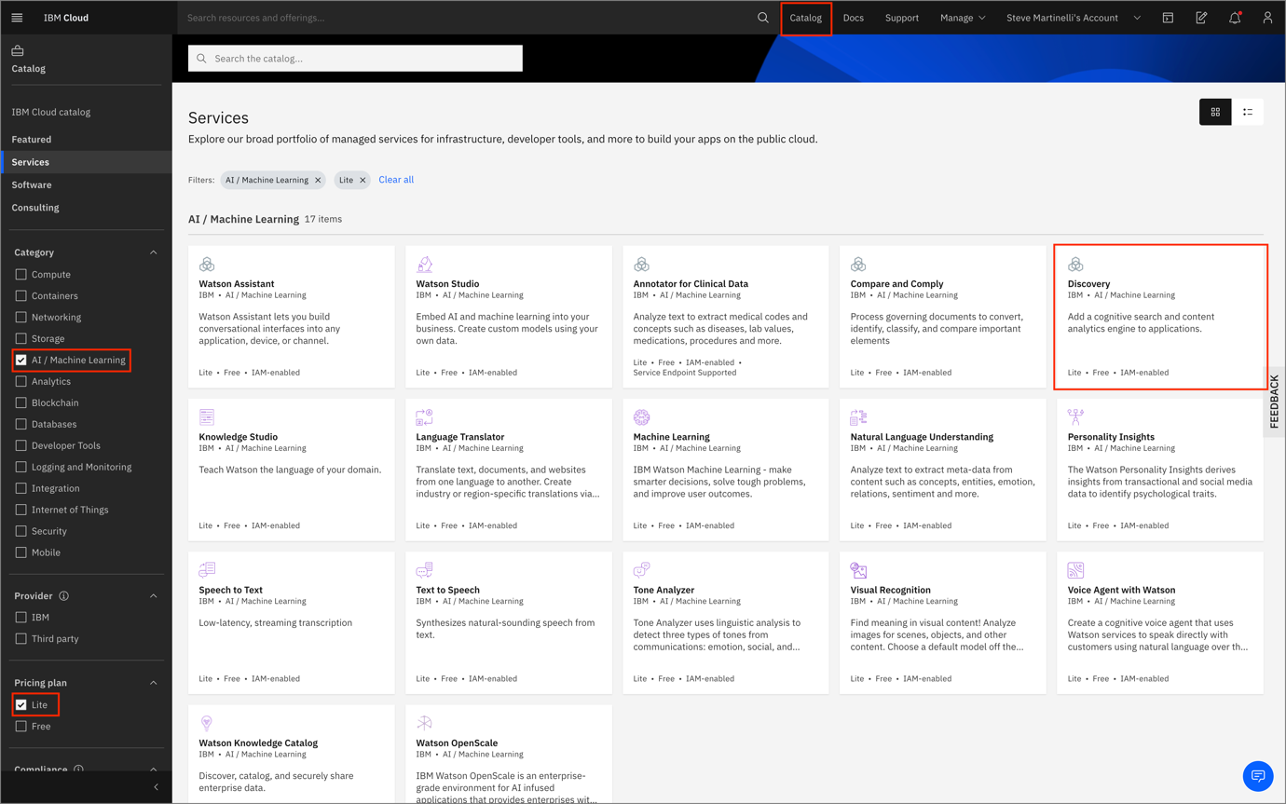

On the next screen, choose a region and then select the **Lite** plan. Next, name the service. Click the **Create** button to continue.

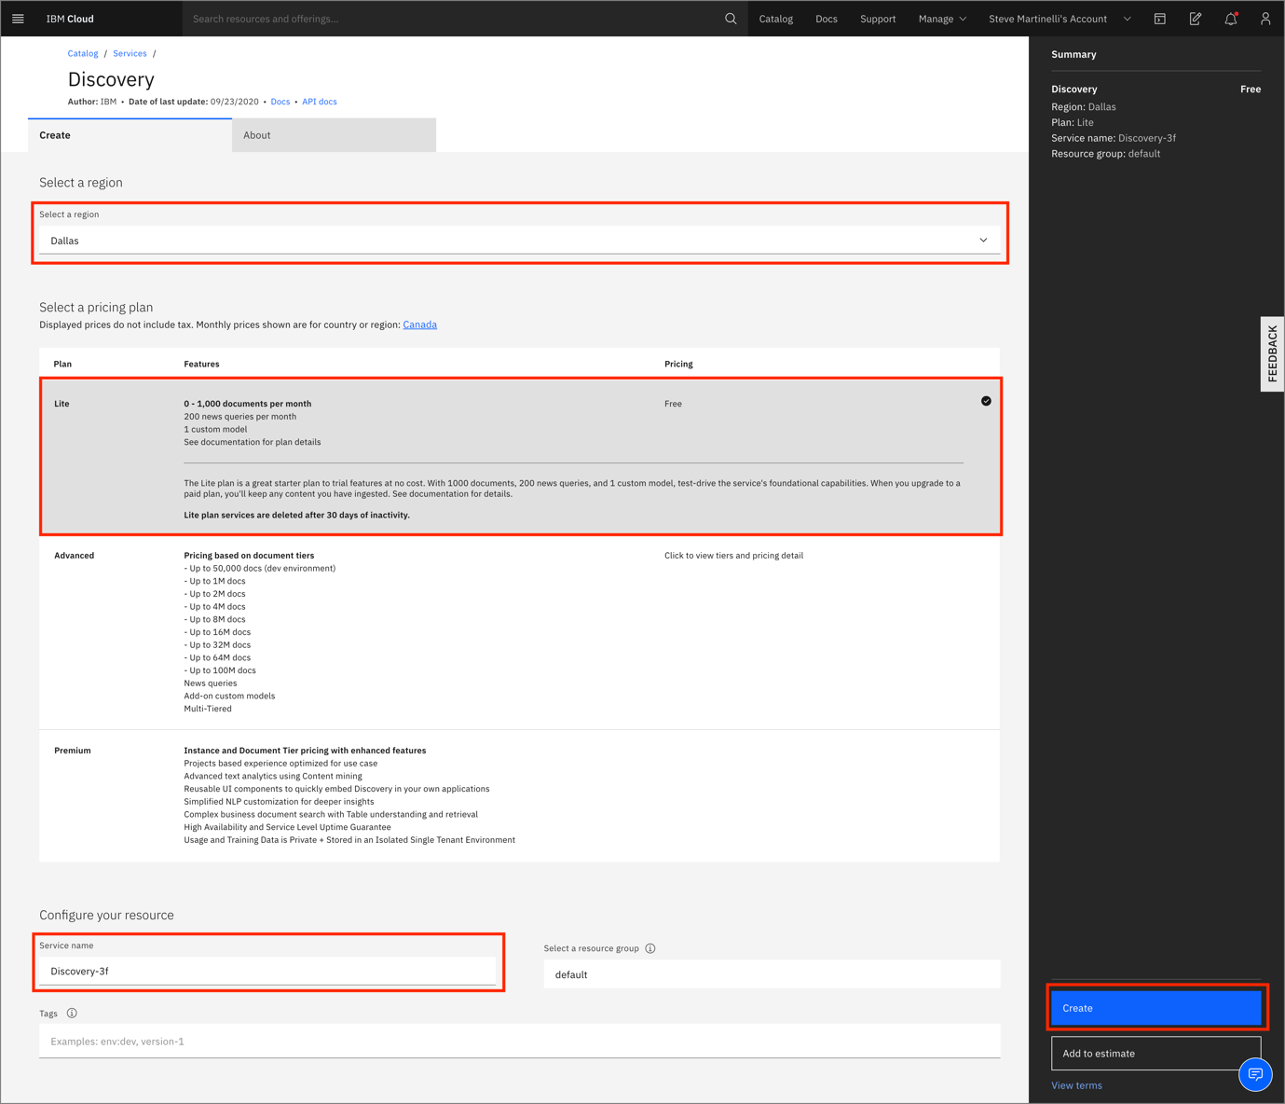

At the Discovery overview screen, click on the **Launch Watson Discovery** button.

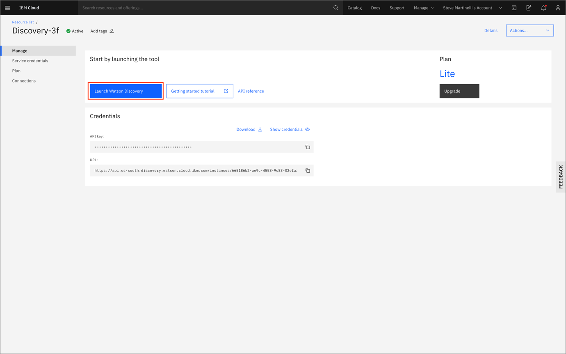

2. Interact with Watson Discovery

Click on the Watson Discovery News tile in the top-left corner.

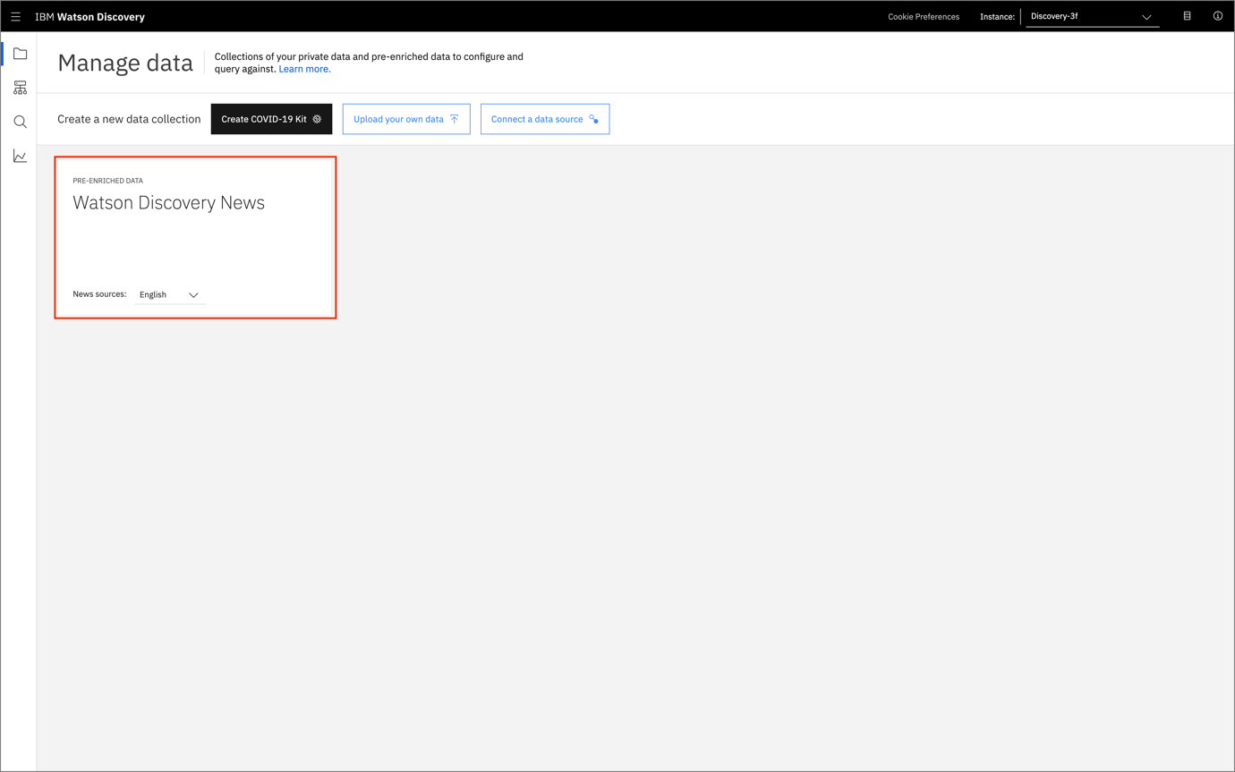

Next, click on the Top 10 companies with positive sentiment button on the right-hand side.

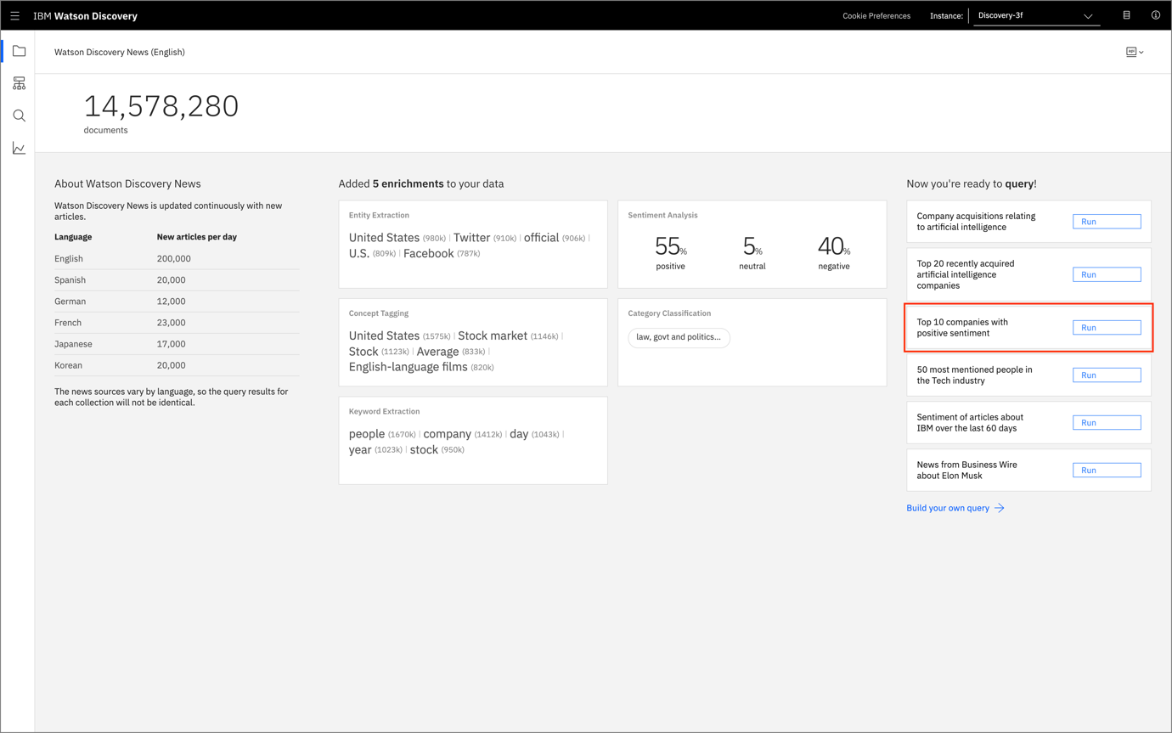

Within the build queries page, you should see the top 10 companies with positive sentiment on the right-hand side. You can also see the number of times they are referenced next to the company name.

Next, click on Search for documents.

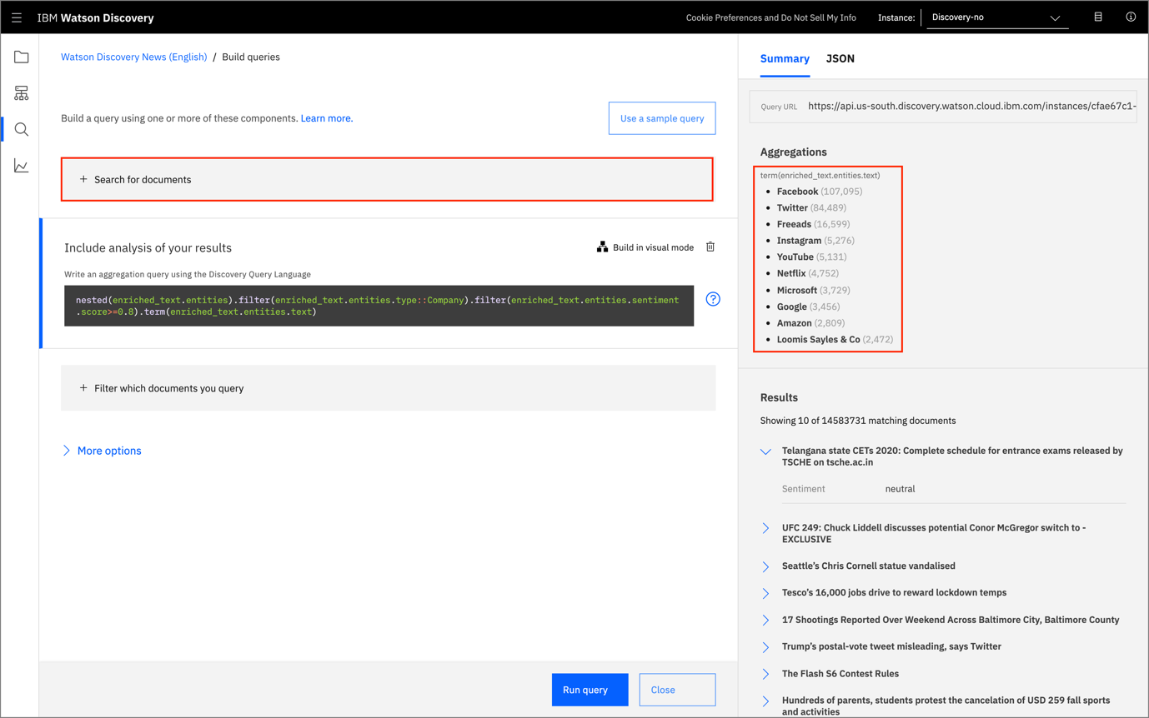

Now, we can use natural language to search for documents within the news. Go ahead and type in What's new with IBM? and click on Run Query at the bottom-right corner of your screen. You'll see all relevant documents in the Results tab at the bottom-right corner of your screen.

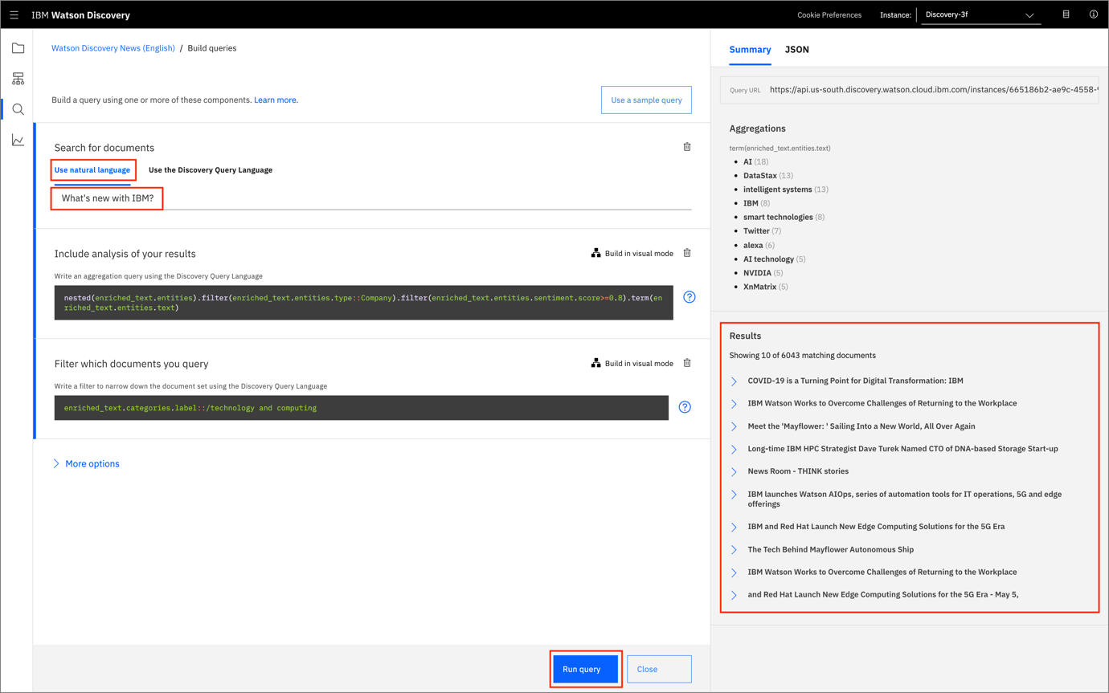

Go ahead and expand the first result by clicking on the greater than symbol next to one of the documents. Once you expand the document, you can see details such as sentiment, keywords, concepts, entities and other information about the document.

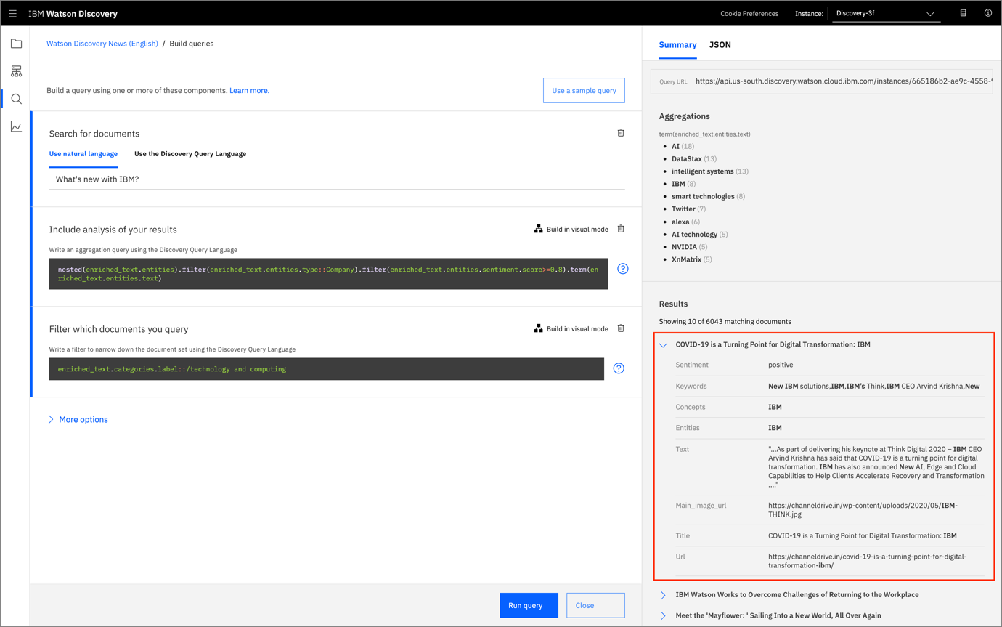

Next, click on the JSON tab at the top part of the page. This will display the resulting information from our queryin JSON format. This will help developers understand how to parse results from Watson Discovery.

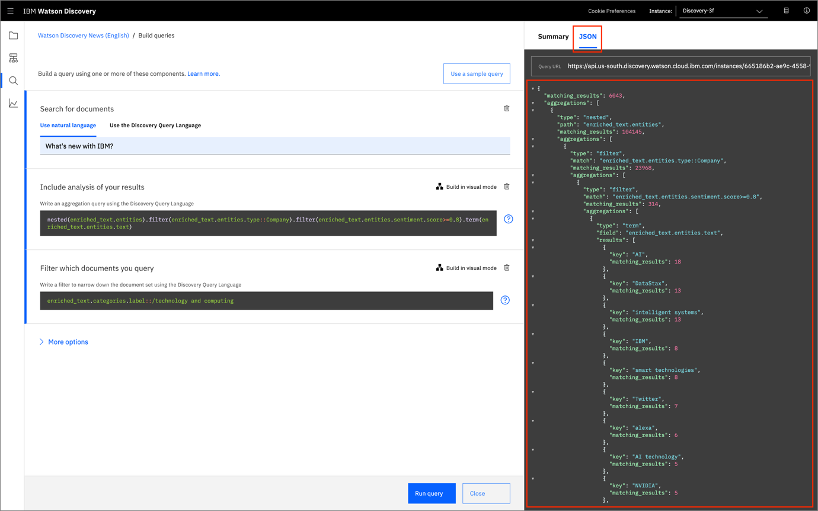

**Congratulations!** You've successfully created a Watson Discovery service, and queried Watson to find the top trending companies in the news with positive sentiment.